PRAS XX00IF Accounts Payable Program
Manual (R12)

Client:
Shared Service Center
Finance and Accounting Department

Author:
Creation Date: January 8, 2015
Last Updated: January 8, 2015
Control Number and Version are marked by a Word Bookmark so that they can be easily reproduced in the header and footer of documents. When you change either of these values, be careful not to accidentally delete the bookmark. You can make bookmarks visible by selecting Tools->Options…View and checking the Bookmarks option in the Show region.

PROCEDURE DETAILS

Log in into Oracle Application 11i using your Username and Password

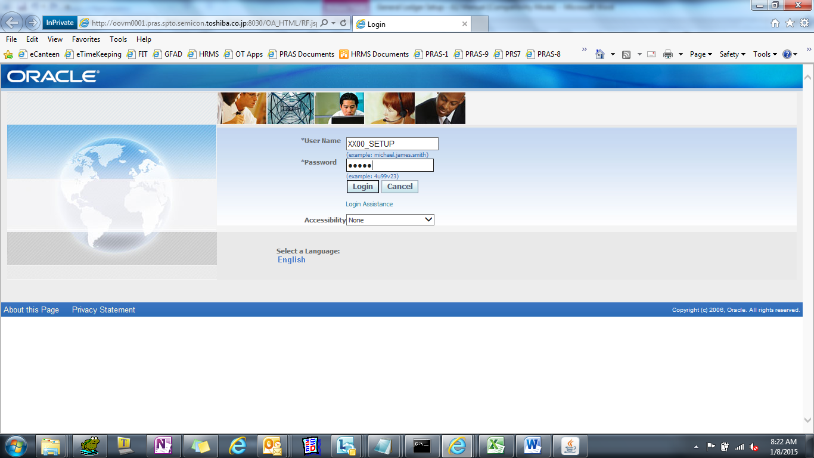

Select TIP AP Add-on System Responsibility
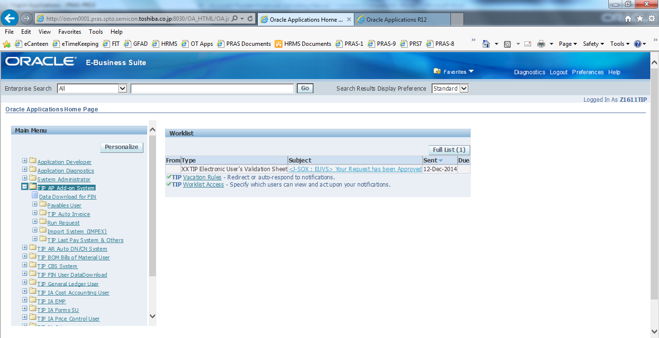

PRAS - GAIA AP Interfacing Process

- XX00IF AP Invoice Extraction Program for Interfacing

(N) Other > Request > Submit a New Request > Single Request
Name : XX00IF AP Invoice Extraction Program for Interfacing
Batch Name : [ Enter Source ]
Period Name : [ Enter Period Name ]
Created By : [ Optional ]

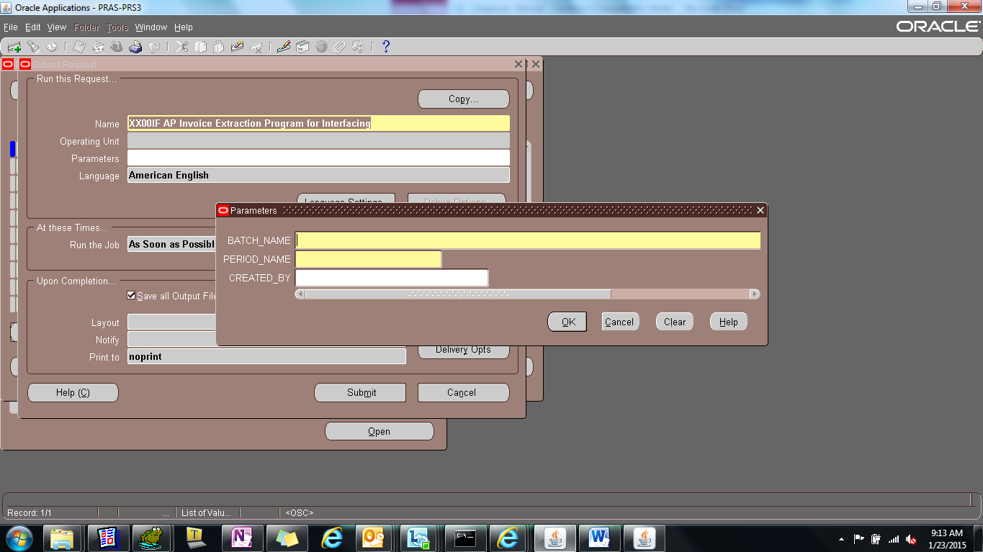
Check the following table(s) :

XX00IFAP_INVOICE_HDR_ STG_ALL
XX00IFAP_INVOICE_LINE_STG_ALL

PROCESS_STATUS : EXTRACTED

View Output Report.
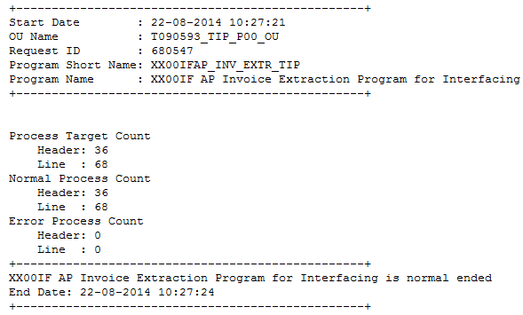
* Process Target Count must be equal to Normal Process Count.
** Error Process Count must be zero.

- XX00IF AP Invoice Conversion and Error Check Program

(N) Other > Request > Submit a New Request > Single Request
Name : XX00IF AP Invoice Conversion and Error Check Program
Created By : [ Optional ]

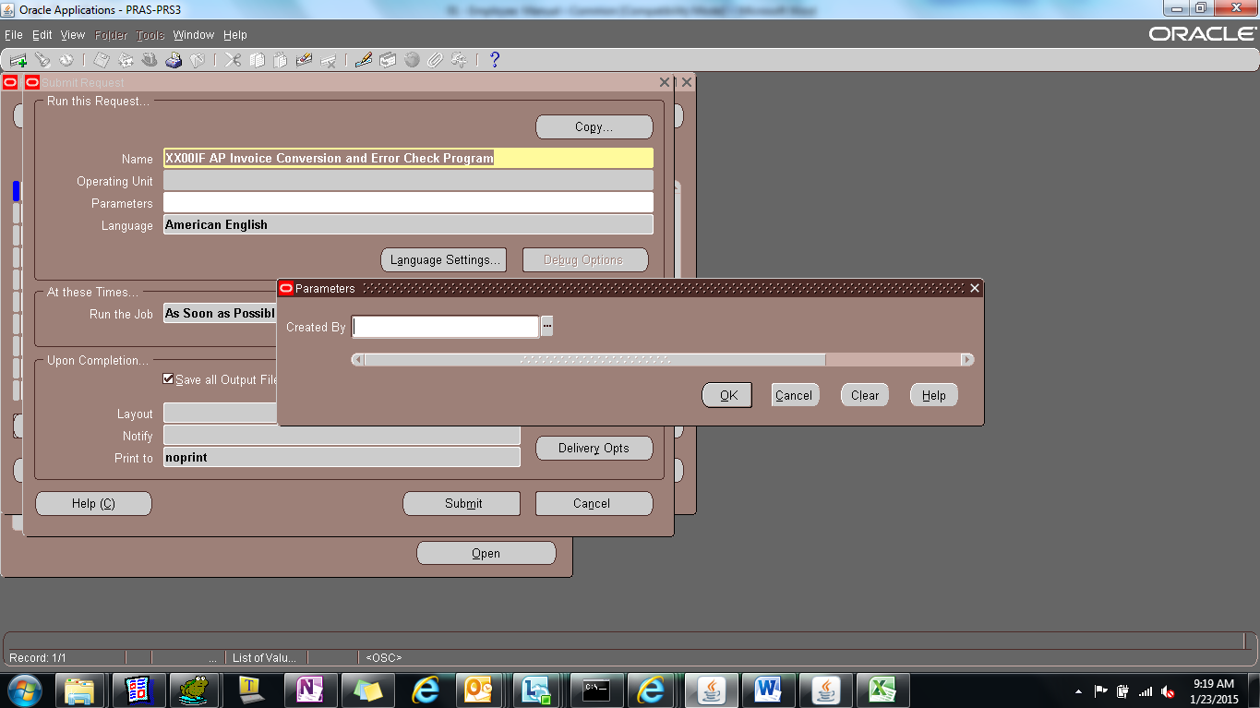
Check the following table(s) :

XX00IFAP_INVOICE_HDR_ STG_ALL
XX00IFAP_INVOICE_LINE_STG_ALL

PROCESS_STATUS : INTERFACED

XX00IFAP_INVOICE_HDR_ IF_ALL
XX00IFAP_INVOICE_LINE_IF_ALL

PROCESS_STATUS : INTERFACED

View Output Report.
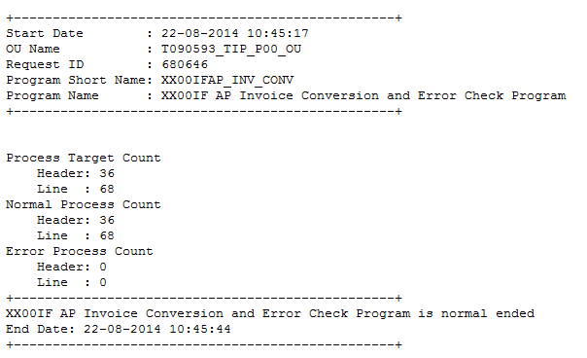
* Process Target Count must be equal to Normal Process Count.
** Error Process Count must be zero.

- XX00IF AP Invoice Data File Creation Program

(N) Other > Request > Submit a New Request > Single Request
Name : XX00IF AP Invoice Data File Creation Program
Entity Name : [ ap ]
Delimiter : [ NULL ]
Journal Source Name : [ NULL ]
Check the following table(s) :

XX00IFAP_INVOICE_HDR_ IF_ALL
XX00IFAP_INVOICE_LINE_IF_ALL

PROCESS_STATUS : INTERFACED
FTP_FILE_NAME : with value

Created By : [ NULL ]

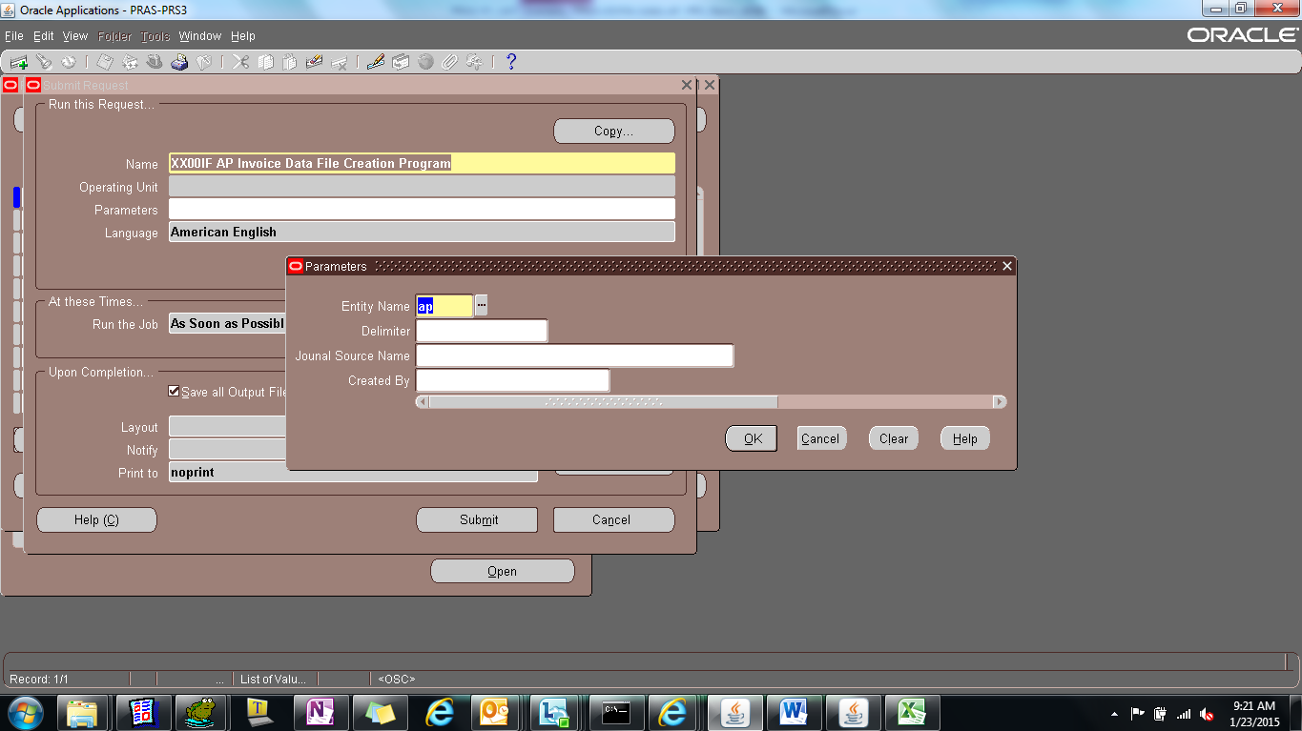

View Logs Report.
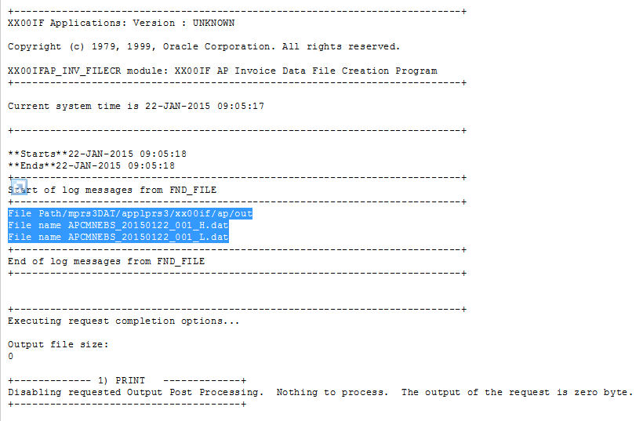

- XX00IF AP Invoice Data File Transfer Program

(N) Other > Request > Submit a New Request > Single Request
Name : XX00IF AP Invoice Data File Transfer Program
Entity: [ ap ]
Check the following table(s) :

XX00IFAP_INVOICE_HDR_ IF_ALL
XX00IFAP_INVOICE_LINE_IF_ALL

PROCESS_STATUS : TRANSFERRED
FTP_FILE_NAME : with value

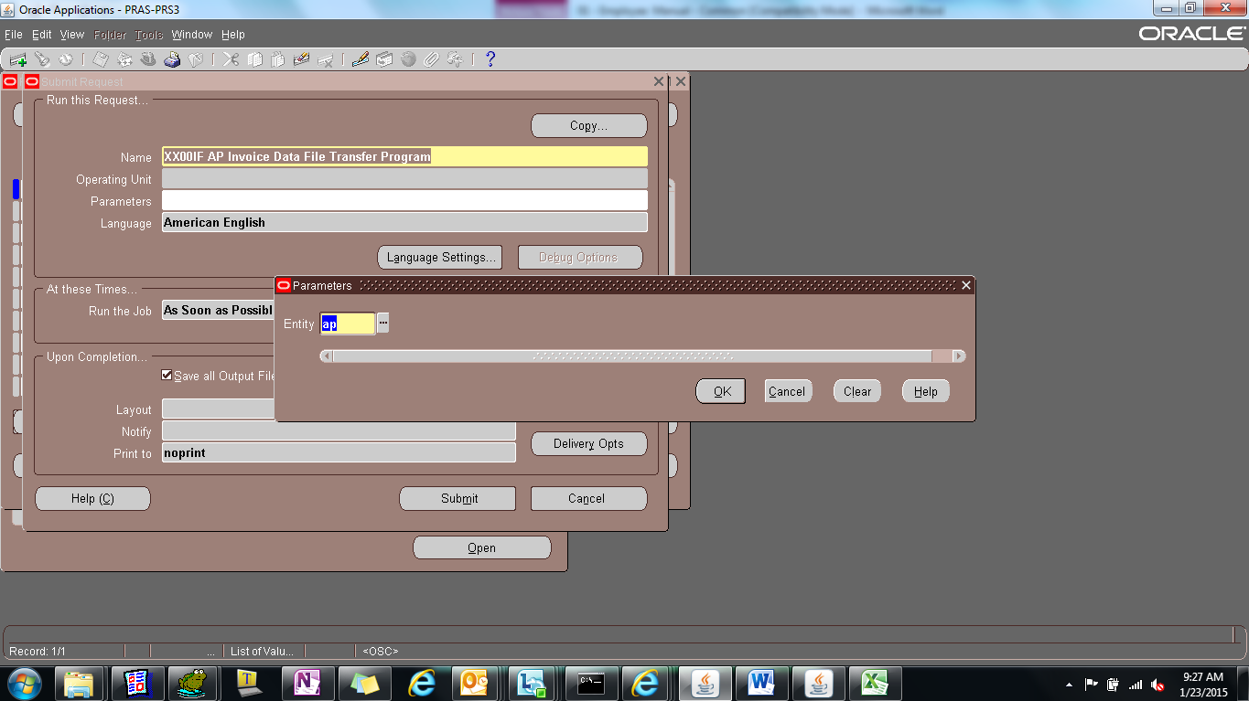

View Logs Report.
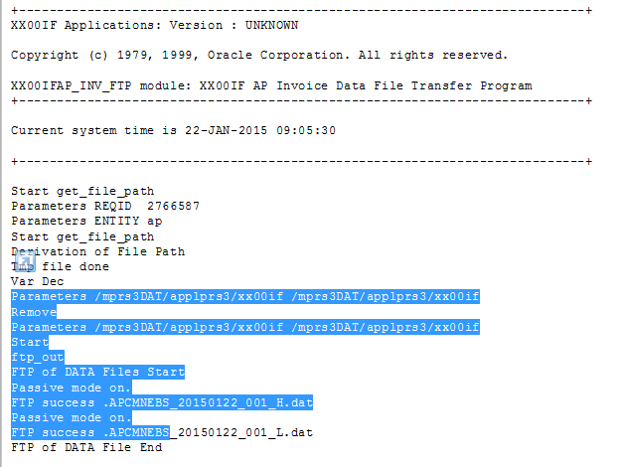

- TIP GAIA outbound report for AP

(N) Other > Request > Submit a New Request > Single Request
Name : TIP GAIA outbound report for AP
Module Name : [ ap ]
Legal Entity : [ T090593 ]
File Name : [ input file name created in file creation program ]

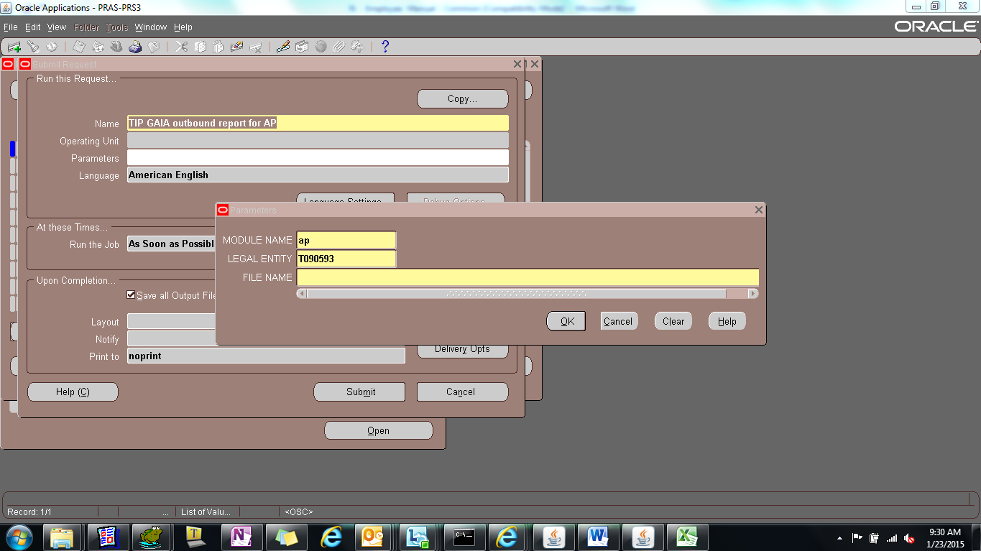

View Output Report.
